**DAILY ONLINE ACTIVITIES SUMMARY**

|  |  |  |  |  |  |  |  |  |
| --- | --- | --- | --- | --- | --- | --- | --- | --- |
| **Date:** | **12/06/2020** | | | | | **Name:** | **Hanan Saleem Baji** | |
| **Sem & Sec** | **4th SEM 'A' Section** | | | | | **USN:** | **4AL18CS024** | |
| **Online Test Summary** | | | | | | | | |
| **Subject** | | Aadalitha Kannada | | | | | | |
| **Max. Marks** | | 25 | | **Score** | | | 24 | |
| **Certification Course Summary** | | | | | | | | |
| **Course** | **1.Ethical Hacking** | | | | | | | |
| **Certificate Provider** | | | **1. Great Learning Academy** | | **Duration** | | | **1. 3 hour** |
| **Coding Challenges** | | | | | | | | |
| **Problem Statement:** 1. Given two positive integer start and end. The task is to write a Python program to print all Prime numbers in an Interval.  .  For example | | | | | | | | |
| **Status: completed** | | | | | | | | |
| **Uploaded the report in Github** | | | | | **Yes** | | | |
| **If yes Repository name** | | | | | 1. <https://github.com/saleemhananbaji/Python-Coding> | | | |
| **Uploaded the report in slack** | | | | | **Yes** | | | |

ONLINE TEST DETAILS: Online test was conducted on all the chapters of **Aadalitha Kannada**. Test contains 25 questions of 1 mark each. I have scored 24 Marks.

Snapshot:

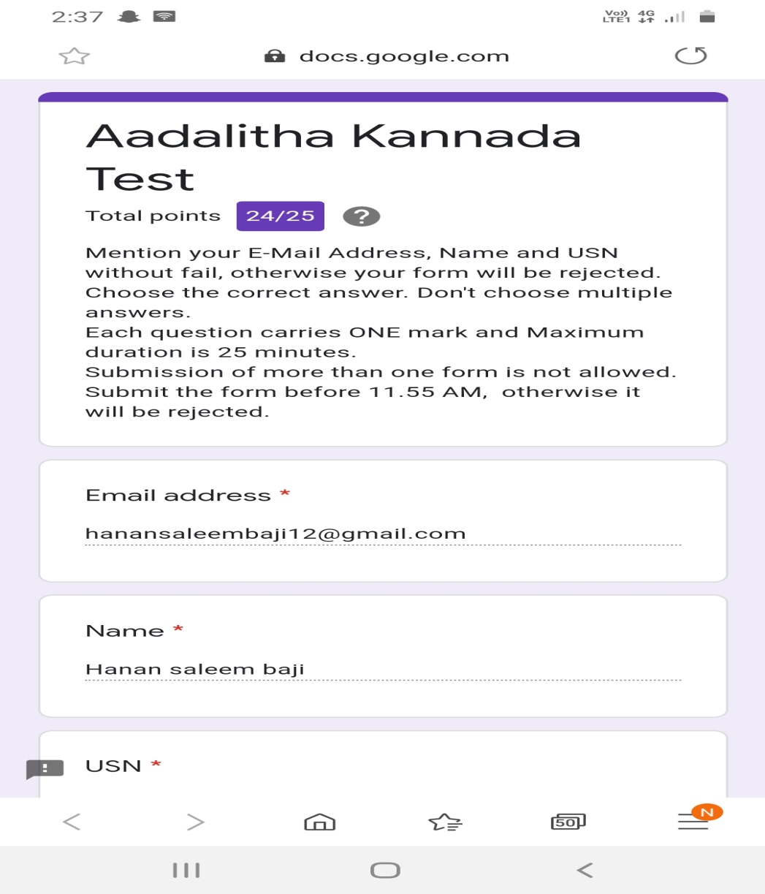

Certification Course Details: As the continuation of online course, I was able to complete what is Ethical Hacking and also I have taken the quiz. The test contains 10 questions of 1 mark each. I have scored 6 marks.

Snapshot:

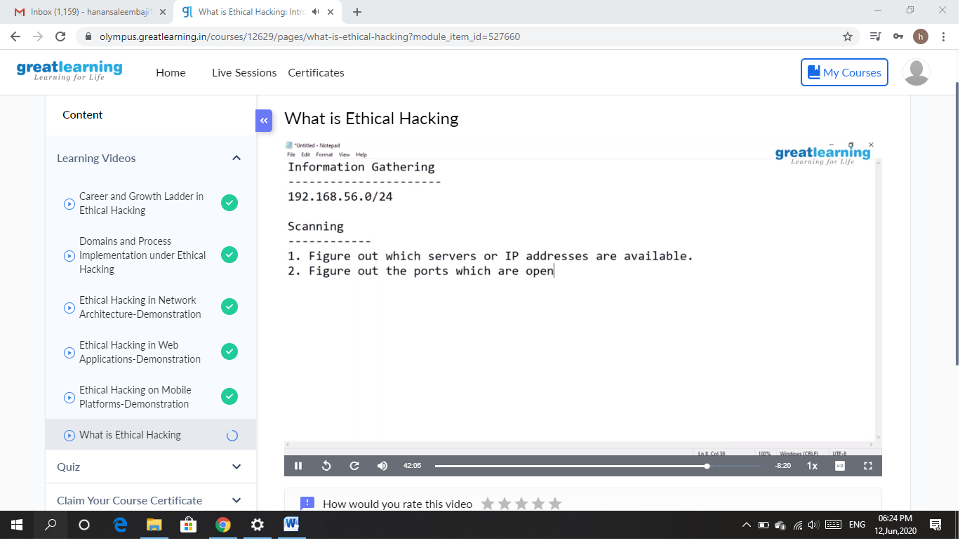

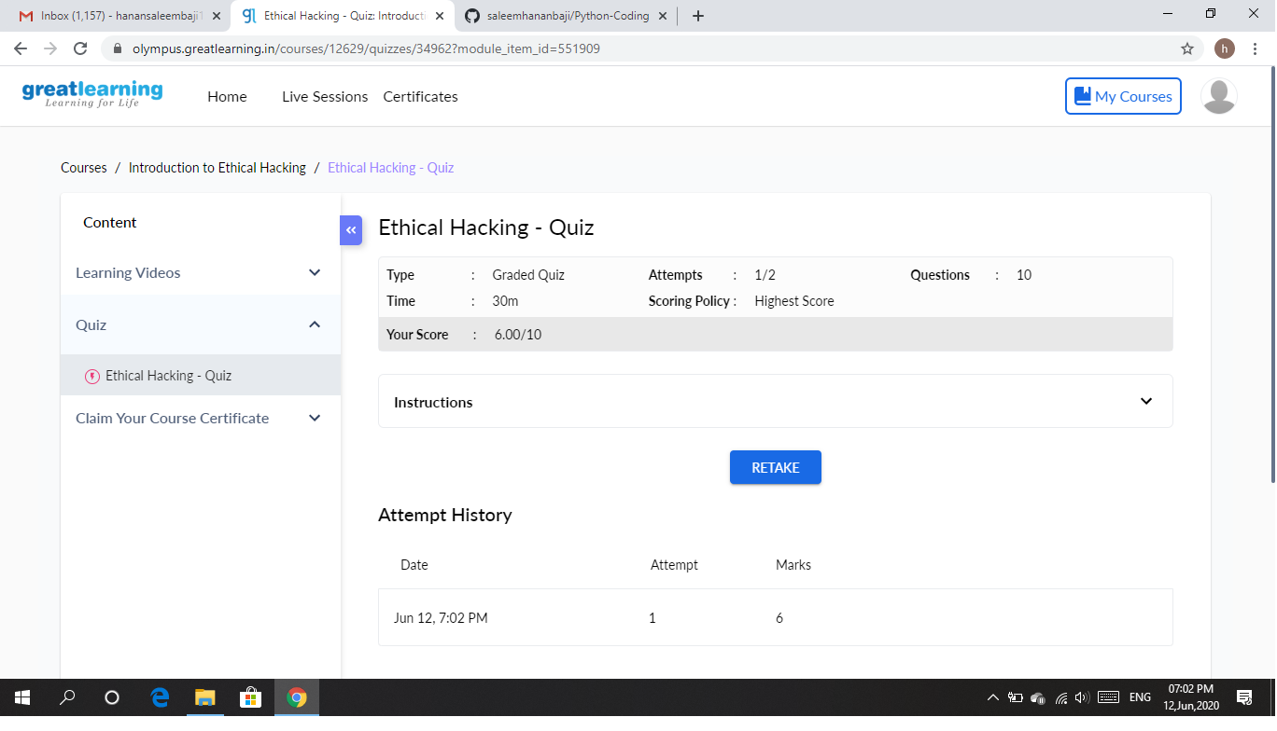

CODING CHALLENGES DETAILS: Problem statements

1. Given two positive integer start and end. The task is to write a Python program to print all Prime numbers in an Interval.

Solution: Uploaded it in github

Snapshot:

